Name_________________________________________Block_____________Date___________  
CO2 Graph and Questions

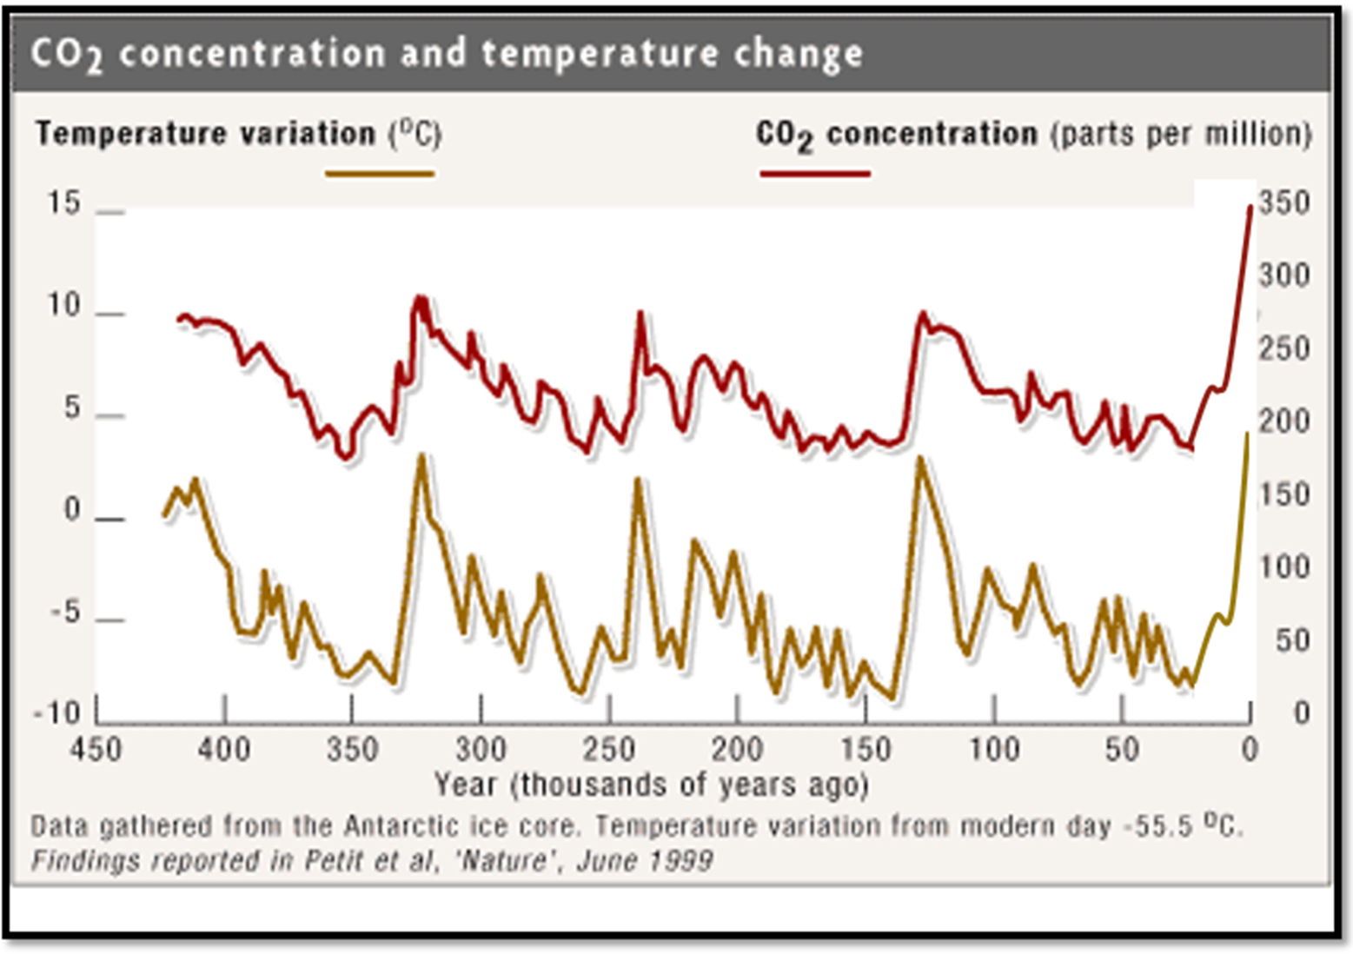

**Analyze the graph and answer the following questions…**

1. What unit is CO2 measured in?
2. How many spikes in global temperature has their been in the past 400,000 years?
3. What is the correlation between the amount of CO2 and the global temperature?
4. What happened to the global temperature after the use of fossil fuels in comparison to the time period before the use of fossil fuels?
5. Do humans have an impact in global warming? Why or why not?



1. **Write a paragraph describing the scientific evidence relating to CO2 and temperature. Use at least 3 pieces of evidence from the graph in your explanation.** (Claim-What is happening in the graphs, Evidence-Use specific information from the graphs, Reasoning-Why is that what’s happening)

____________________________________________________________________________________________________________________________________________________________________________________________________________________________________________________________________________________________________________________________________________________________________________________________________________________________________________________________________________________________________________________________________________________________________________________________________________________________________________________________________________________________________________________________________________________________________________________________________________________________________________________________________________________________________________________________________________________________________________________________________________________________________________________________________________________________________________________________________________________________________________________________________________________________________________________________________________________________________________________________________________________________________________________________________________________________________________________________________________________________________________________________________________________________________________________________________________________________________________________________________________________________________________________________________________________________________________________________________________________________________________________________________________________________________________________________________________________________________________________________________________________________________________________________________________________________________________________________________________________________________________________________________________________________________________________________________________________________________________________________________________________________________________________________________________________________________________________________________________________________________________________________________________________________________________________________________________________________________________________